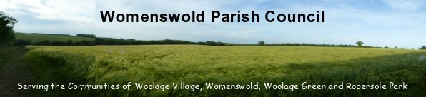

WELCOME PACK

NEW COUNCILLOR
INDUCTION

Table of Contents

1. | Introduction to Womenswold Parish Council
 | 1.1 | Womenswold history and background……………………………… |  | 3
 | 1.2 | Womenswold boundary map…………………………………………. |  | 4
2. | How the local council works and useful information
 | 2.1 | The role of local councils……………………………………………….. |  | 4
 | 2.2 | What is a Parish council?...................................................................... |  | 5
 | 2.3 | Local councillors…………………………………………………………. |  | 6
 | 2.4 | Local council staff………………………………………………………... |  | 7
 | 2.5 | Staff Structure…………………………………………………………… |  | 7
 | 2.6 | Council Meeting Dates………………………………………………….. |  | 7
 | 2.7 | Chairman and Committee membership…………………………….. |  | 8
 | 2.8 | Useful telephone numbers and links…………………………………. |  | 10
3. | Governance…………………………………………………………................ |  |  | 12
4. | Councillor Behaviour……………………………………………………….. |  |  | 12
5. | Policies and Procedures…………………………………………………… |  |  | 13
6. | Audit………………………………………………………………… |  |  | 14

1. Introduction to Womenswold

1.1 Womenswold history and background
Womenswold is a village and civil parish centred 7 miles (11 km) south-east of Canterbury, Kent, England, 1 mile to the east of the A2 road. The parish consists of three hamlets: Womenswold, Woolage Village and Woolage Green.
Historically, Womenswold has been recorded with various spellings, including Wymynswold and Wimlingswold. A further one may be Wymelyngewolde.
Originally 'Wymelyngewolde', from the combination of the possible personal name of ‘Wimel’ and the Old English ‘ingas’ meaning the ‘people of’ and ‘wald’ as a ‘forest’. Thus Womanswold, or 'Wymelyngewolde', means the ‘forest of the people of Wimel’.
The church of St, Margaret of Antioch covers all three hamlets, in Womenswold proper rather than the woodland, cereal and pasture fields within its bounds. A small mediaeval building without any side aisles, it is part of the Barham Downs group of churches.

The Parish Council is responsible for maintaining the church yard, the play equipment and the following open spaces:

Woolage Green, Recreation Ground, Strimming Signs, Beacon, Layby.

1.2 Womenswold Boundary Map
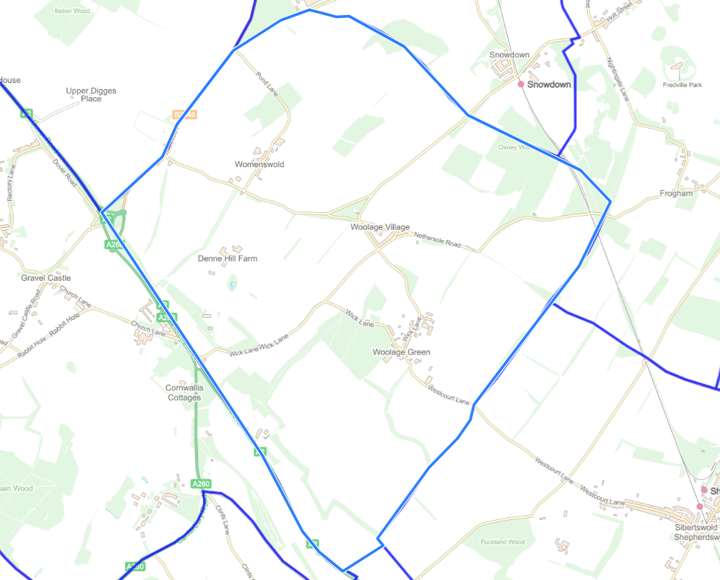

2. How the local council works and useful information

2.1 The role of local councils
Local councils are a type of local authority. They do not exist everywhere in England and Wales.
Local councils have a range of specific statutory powers which they may exercise if and only if they wish to.
Allotments is the only statutory duty.
Powers include:
· Burial Grounds, Cemeteries, Churchyards and Crematoria
· Bus Shelters
· Bye-laws – the power to make bye-laws concerning: baths and washhouses (swimming pools), cycle parks, mortuaries and pleasure grounds
· Clocks – public clocks can be provided and must be maintained
· Community Centres, Conference Centres, Halls, Public Buildings
· Drainage – of ditches and ponds
· Entertainment and the Arts
· Footpaths
· General Spending – parish councils can spend a limited amount of money on anything they deem of benefit to the community that is not covered by the other specific responsibilities described in this list
· Gifts – parish councils may accept gifts
· Highways – lighting, parking places, right to enter into discussions about new roads and road widening, consent of parish council required for diversion or discontinuation of highway, traffic signs and other notices, tree planting and verge maintenance
· Land – acquisition and sale of
· Legal proceedings – power to prosecute and defend any legal proceedings in the interests of the community, power to take part in any public enquiry
· Litter - provision of litter-bins and support for any anti-litter campaigns
· Planning – parish councils may be notified of any planning applications for the area
· Postal and Telecommunication Facilities – power to pay a public telecommunications operator any loss sustained in providing services in that area
· Public conveniences – provision and maintenance of public toilets
· Recreation – provision of recreation grounds, public walkways, pleasure grounds, open spaces, village greens, gymnasiums, playing fields, holiday camps and boating ponds
· Rights of Way – footpath and bridleway maintenance
· Seats (public)
· Signs – danger signs, place names and bus stops signs
· Tourism – financial contributions to any local tourist organisations allowed
· Traffic Calming
· War Memorials
· Water Supply – power to utilise stream, well or spring water and to provide facilities for general use
Local councils do not have statutory responsibility for services such as waste collection, street parking, traffic regulation, environmental health, street trading, planning and building control, licensing, housing, education, development control or social care functions for the area that they represent. Statutory responsibility for the discharge of those functions rests with other types of local authority.
Local councils have a statutory power to precept (tax) the local government electors in their areas to finance the activities that flow from the exercise of their discretionary powers and subsequent legal obligations. The precept is a component of the council tax levied on the local government electors in the area of the local council.
Most decisions about local council business are taken at formal meetings of the council.
2.2 What is a Parish Council?
Parish Councils are the first tier of local government and are statutory bodies. They serve electorates, are independently elected, and raise their own precept (a form of council tax). There are 10,000 local councils in England with over 30% of the country parished and 100,000 councillors who serve in these local councils, with over £1b being invested into these communities every year.
Parish councils work towards improving community well-being and providing better services. Their activities fall into three main categories: representing the local community; delivering services to meet local needs; striving to improve quality of life and community well-being.
Through an extensive range of discretionary powers local councils provide and maintain a variety of important and visible local services including allotments, bridleways, burial grounds, bus shelters, car parks, commons and open spaces, community transport schemes, community safety and crime reduction measures, events and festivals, footpaths, leisure and sports facilities, litter bins, public toilets, planning, street cleaning and lighting, tourism activities, traffic calming measures, village greens and youth projects.
Womenswold Parish Council is committed to being an open and accountable public body. To promote transparency and easy to understand engagement with our residents we have agreed to adopt a policy that we use clear plain English in all our communications.
More information on content and design can be found on gov.uk website:
https://www.gov.uk/guidance/content-design/updates

2.3 Local councillors
Key points:
- A councillor’s normal term of office is four years.
- Any person over 18 who is a citizen of the UK, the EU or the Commonwealth can be a councillor if they are an elector in, work in, live in or live within three miles of the area of the local council, unless they are disqualified.
- The first business of the annual meeting of the local council is the election of its Chair.
- Most councils appoint a Vice-Chair, but this is optional.
- The normal term of office for the Chair and Vice-Chair (if there is one) of a local council is one year.
- A councillor is the holder of a public office, not a volunteer.
- A councillor can receive expenses for this role.
- A councillor has no authority to make decisions about council business on his own.
- The main job of a councillor is to participate in the collective decision-making processes of the council.
- A local council may arrange insurance cover to indemnify its councillors against liability resulting from them being representatives of the council.
- A councillor’s financial and certain other interests in council business must be transparent.
- A councillor is subject to obligations set out in the code of conduct adopted by the council.
- Information about councillors is available in the council’s publication scheme.

2.4 Local council staff
Key Points:
Local council staff may:
- Include person(s) to undertake statutory obligations conferred on the “Responsible Financial Officer”.
- Include person(s) to undertake statutory obligations conferred on the “Proper Officer”.
- Are needed to support a council’s general administration, and accounting and audit administration.
- May provide or manage a council’s services and facilities.
- May discharge some of a council’s statutory powers and functions on the council’s behalf.
- Cannot be councillors in the same council.
- Cannot be managed by individual councillors

2.5 Staff Structure
Womenswold Parish Council operates with one member of staff, acting as Clerk and Responsible Financial Officer.

2.6 Council Meeting Dates
Meeting dates are set at the Annual General Meeting every May. A parish council must hold at least three meetings each year.

2.7 Useful telephone numbers and links

SERVICES | UTILITIES |  | LOCAL COUNCILS | FOR DISTRICT | HOSPITALS
POLICE  101 (non-emergency) | ELECTRICITY 105  Number to report a power cut or an electricity network safety issue. |  | KENT COUNTY COUNCIL  03000 41 91 91 | Mobile library service  Alternate Friday 3:30pm - 4pm (blue route)  03000 41 31 31  doverlibrary@  kent.gov.uk | The Chaucer Hospital  Nackington Road  Canterbury  Kent  CT4 7AR  01227 825100
CRIMESTOPPERS  0800555111 | GAS  National Gas Emergency Service 0800 111999 |  | CANTERBURY CITY COUNCIL  01227 862000 | PARKING | St Martin's Hospital  Littlebourne Road, Canterbury, Kent, CT1 1AZ  01227 812000
NHS  111 (24 hr) |  |  |  | PARKING  CANTERBURY CITY COUNCIL  01227 862000 | Kent and Canterbury Hospital  Kent and Canterbury Hospital, Ethelbert Road, Canterbury, Kent, CT1 3NG  01227 766877
CHILDLINE 08001111

USEFUL LINKS

Womenswold Parish Council |  | www,womenswoldparishcouncil.gov.uk
Canterbury City Council |  | www,canterbury.gov.uk
Trains |  | www.southeastern.co.uk
Post Office Near  Me |  | Aylesham Market Place, Aylesham, Canterbury, CT3 3DZ  Barham Valley Road, Barham, Canterbury, CT4 6NX
Air Quality |  | www.kentair.org
Dog warden service |  | www.canterbury.gov.uk/environmental-problems/report-lost-dog  01227 290 069
Kent Library Service |  | www.kent.gov.uk/leisure-and-community/libraries
Parking |  | https://www.canterbury.gov.uk/parking-and-roads

- Governance
As Policies are created or updated they are added to the Parish council website under policies and procedures.
Please read the following governance as these will explain how the council functions.
- Standing Orders
- Terms of Reference and Delegations
- Financial Regulations

The Parish council has agreed a Project Plan policy to oversee the introduction of any new project spending.
If you wish the council to discuss an idea or project you can raise a motion. The motion must be raised inline with the Standing Orders and put before the committee with the delegated authority to act. If in doubt, you can seek advice from the Proper Officer (the Parish Clerk).
- Councillor Behaviour
You will be given a copy of the Good Councillor Guide. Please read this very carefully and ensure that you have completed your Declarations of Interest form within 28 days of appointment. The Code of Conduct is available here:
Policies and Procedures - Womenswold- Bexhill-on-Sea, Womenswold(bexhillParishcouncil.gov.uk)
Complaints about councillor behaviour are investigated by Rother District Council.
- Policies and Procedures
As mentioned above all Policies can be found on the Parish Council website under policies and procedures.
GDPR policies can be viewed on the council website under Data Protection and GDPR.
- GDPR Data Privacy Notice
- Freedom of Information Policy
- Data Protection Policy

The guidance from the Information Commissioners Office is available here:

Parish Councils Resource Pack (ico.org.uk)

- Audit
The council’s accounts are audited twice a year by an internal auditor and once a year by an external auditor.
The Annual Governance and Accountability Return (AGAR) is completed and approved by the Full Council by deadlines set in legislation.
The Practitioners Guide lays out all the proper practices for Parish and Parish Councils.
file (nalc.gov.uk)

